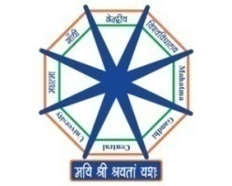

MAHATMA GANDHI CENTRAL UNIVERSITY, BIHAR
[A Central University established by an Act of Parliament]

HONORARIUM RECEIPT

Dated: ________________________

Received with thanks a sum of ₹____________________________________ (Rupees ________________________________________________________________________) only on account of Sitting Fee for attending _______________________________________________________________________ ________________________________________________________________________Meeting held on ____________________________________ at ____________________________________________________________ ________________________________________________.

Signature: ____________________________________

Name : ____________________________________
Bank Account Details:
Name of the Beneficiary
Name of the Bank
Bank Account No.
IFSC Code
PAN

